SUM OF CUBE

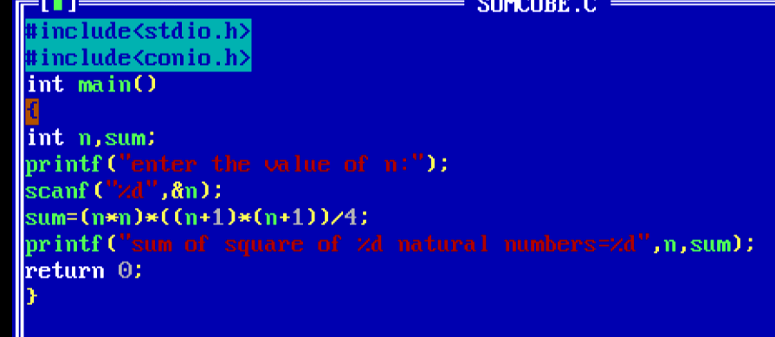  
OUTPUT

